G.A.D.D. (God Against Drunk Drivers)!
God hates booze! You see, God thinks the exact OPPOSSITE as the beer companies. The beer producers argue that if 99% of beer drinkers can handle it, then there’s no problem with the beer. However, it’s that 1% that murder tens-of-thousands of innocent people every year. And there’s NO WAY of knowing who the 1% are, which is proven by the statistics. Jesus was willing to leave the 99 because He genuinely CARED about that one lost individual. Jesus stated in Luke 15:7, “I say unto you, that likewise joy shall be in heaven over one sinner that repenteth, more than over ninety and nine just persons, which need no repentance.” In sharp contrast to society today in general, God CARES about the individual. Unfortunately, the beer companies, sellout politicians, and the cut-throat lawyers DON’T care about the victims of alcohol-related abuse. How many more people have to become victims? How many more hundreds-of-billions of dollars do American taxpayers have to pay in damages because of the evils associated with alcoholic beverages? I say MAKE THE BEER MERCHANTS PAY ALL THE COSTS!!! It is evil to expect taxpayers to foot the bill for alcoholics! Please visit the website:
http://www.beersoaksamerica.org
“Whiskey and beer are all right in their place, but their place is in hell.” -Billy Sunday
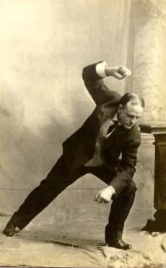
The only safe bet is to avoid alcohol completely. You can’t take two drinks if you don’t take the first. It only takes one drink to ruin your life, or someone else’s.

“Look not thou upon the wine when it is red, when it giveth his colour in the cup, when it moveth itself aright. At the last it biteth like a serpent, and stingeth like an adder. Thine eyes shall behold strange women, and thine heart shall utter perverse things.” –Proverb 23:31-33
Our website: www.Jesus-is-Savior.com
Do You Know the Truth about Beer?
Not every one who gets hit by a drunk driver dies!

What You Need to Know!

Beer Is More dangerous than people think
What is drunk driving? This term is an inaccurate characterization of the problems caused by motorists who are impaired by alcohol. The first criminal laws targeting this problem prohibited "drunk driving," encouraging the notion that the problem was restricted to drivers who were visibly drunk. In fact, many alcohol-impaired drivers do not appear drunk in the traditional way. Research has shown that even small amounts of alcohol can impair the skills involved in driving, but the persistent notion that the problem is predominantly one of drunk drivers has allowed many drinking drivers to decide they are not part of the problem. For these reasons, the term "alcohol-impaired driving" is a more accurate and precise description of what is commonly referred to as drunk driving.
The National Highway Traffic Safety Administration's (NHTSA) position on the relationship between blood alcohol concentration and driving is that driving performance degrades after just one drink."
SOURCE: http://www.nhtsa.dot.gov/people/injury/New-fact-sheet03/Point08BAC.pdf
This is a shocking fact, because millions of Americans drive motorized vehicles each day after having a drink or two of beer. The results have been disastrous and tragic!
Don’t you see? … the beer companies are LIARS! They propagate the hypocritical nonsense that a person can drink alcohol “responsibly.” That’s equivalent to saying that a person can play Russian roulette responsibly (You know, the game where each person puts one bullet into a 6-shot gun, spins the barrel, and then takes turns pulling the trigger until someone dies). There is a great DECEIT inherent to alcohol, and the Word of God states this in Proverb 20:1 … “Wine is a mocker, strong drink is raging: and whosoever is deceived thereby is not wise.”
"The saloon is the sum of all villainies. It is worse than war or pestilence. It is the crime of crimes. It is the parent of crimes and the mother of sins. It is the appalling source of misery and crime in the land. And to license such an incarnate fiend of hell is the dirtiest, low-down, damnable business on top of this old earth."
-Billy Sunday (Quoted from the sermon, The Curse of the Saloon)
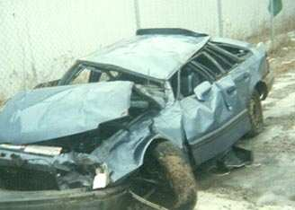
- Fact: Beer is the drink most commonly consumed by people stopped for alcohol-impaired driving or involved in alcohol-related crashes.
- Fact: In 2001, more than half a million people were injured or disfigured in crashes where police reported that alcohol was present — an average of one person injured approximately every minute. One third of these were children.
http://www.nhtsa.dot.gov/people/injury/alcohol/impaired_driving_pg2/US.htm

